Rayat Shikshan Sanstha’s
Yashvantrao Chavan Institute Of Science Satara
Constituent College of Karmveer Bhaurao Patil University Satara


PROJRCT NAME : Trip Planner
BY
Nisha Hanmant Kadav.

Under Guidence Of Mr. A.Y.Tilekar
B.Voc
( SOFTWARE DEVELOPMENT )



YASHVANTRAO CHAVAN INSTITUTE OF SCIENCE SATARA

This is to certify, Nisha Hanmant Kadav of Software Development have Successfully completed the project work Trip Planning during the academic year 2025-26 this report is submitted as partial fulfilment of the requirement of degree in B.voc Software Development of KBP University Kolhapur.

Project Guide Examiner Head Of Department

Introduction Of Project
The Trip Planner is a Java-based application designed to assist users in organizing and managing their travel plans efficiently. With the growing need for personalized travel experiences, this project aims to simplify the process of planning trips by providing a user-friendly platform to schedule destinations, accommodations, transportation, and activities.
The application allows users to:
- Create and manage itineraries: Users can add destinations, travel dates, and important notes for each trip.
- Plan routes and schedules: The system can suggest an optimized sequence of activities or stops.
- Store travel-related information: Users can save hotel bookings, flight details, and local attractions for quick access.
- Enhance user experience: By providing an organized overview of the trip, it minimizes confusion and ensures a smooth travel experience.
Developed in Java, this project leverages object-oriented programming concepts such as classes, objects, inheritance, and collections to efficiently manage trip data. The application can be extended further with features like cost estimation, map integration, or user authentication to make it more comprehensive.
In essence, the Trip Planner in Java is a practical tool for travelers, combining convenience, organization, and intelligent planning into a single application.

Objectives of Project.

- Simplify Trip Planning:
To provide users with an easy-to-use platform to plan their trips efficiently, including destinations, schedules, and activities.
- Organize Travel Information:
To store all travel-related details such as hotel bookings, flight information, local attractions, and important notes in a structured manner.
- Optimize Itinerary Management:
To help users create an optimized itinerary, suggesting the best sequence of visits and activities to save time and resources.
- Enhance User Experience:
To offer a user-friendly interface that allows users to manage multiple trips, view schedules at a glance, and make adjustments easily.
- Support Decision Making:
To assist users in making informed travel decisions by consolidating information like travel dates, transport options, and accommodation details.
- Encourage Reusability and Extensibility:
To develop the project using modular and object-oriented Java programming principles, allowing for easy maintenance and future feature additions.

Scope of The Project

The Trip Planner in Java is designed to serve as a comprehensive tool for individuals and small groups to plan, organize, and manage their trips efficiently. The scope of this project includes:
- Trip Management:
Users can create, edit, and delete multiple trips, each with details like destination, travel dates, and purpose of the trip.
- Itinerary Planning:
Users can add activities, attractions, or events to each day of the trip, enabling an organized schedule.
- Storage of Travel Information:
The system can store important travel-related information such as accommodation details, transportation options, and contact information.
- User-Friendly Interface:
The application will provide a simple and intuitive interface for easy navigation and interaction.
- Optimized Planning Assistance:
The system can help users optimize their trip schedules by logically sequencing activities and suggesting efficient routes (basic level).
- Data Persistence:
Users’ trip data can be saved and retrieved, allowing them to view and modify their trips over time.
- Extendable Architecture:
The project is designed using object-oriented principles in Java, making it possible to add advanced features in the future, such as cost estimation, map integration, or notifications.

The Existing System
In the current or existing scenario, travelers often face challenges in planning and organizing their trips due to the lack of a centralized system. The common characteristics of the existing system are:
- Manual Planning:
Most trip planning is done manually using notebooks, spreadsheets, or separate apps, which can be time-consuming and prone to errors.
- Scattered Information:
Details such as flight bookings, hotel reservations, places to visit, and daily schedules are stored in different locations, making it difficult to track all information in one place.
- No Optimization:
Users have to plan the sequence of activities themselves without any guidance or optimization, which may lead to inefficient use of time during the trip.
- Limited Accessibility:
If planning is done on paper or offline tools, it is difficult to access or modify trip details while traveling.
- No Historical Data Management:
Travelers cannot easily refer to past trips, budgets, or itineraries for future planning since records are not centralized or structured.
- Higher Chances of Errors:
Manual methods increase the likelihood of missing bookings, scheduling conflicts, or forgetting important details.

The Purposed System

The purpose of this project is to provide a computerized solution for planning and managing trips efficiently. It aims to overcome the challenges of the existing manual system and offer a structured, organized, and user-friendly platform for travelers.
Key purposes include:
- Simplify Trip Planning:
To make it easier for users to plan destinations, activities, and schedules without confusion or missed details.
- Centralize Travel Information:
To store all travel-related details—such as accommodations, transport, attractions, and itineraries—in one place for easy access and management.
- Optimize Time and Resources:
To help users organize their trips efficiently, ensuring better time management and reducing unnecessary travel or delays.
- Improve User Experience:
To provide a convenient and interactive system that minimizes manual effort and enhances trip organization.
- Support Future Planning:
To maintain records of past trips, helping users in planning future travels based on previous experiences.

Input Output Request Inputs :
Input:
Program:
import java.sql.*;
import java.util.Scanner;

public class TripPlanner {

Connection con;

// Constructor to connect to the database
TripPlanner() {
try {
Class.forName("com.mysql.cj.jdbc.Driver");
con = DriverManager.getConnection(
"jdbc:mysql://localhost:3306/trip_db", "root", ""
);
System.out.println("Database Connected!");
} catch (Exception e) {
System.out.println(e);
}
}

// Add a new trip
void addTrip() {
try {
Scanner sc = new Scanner(System.in);

System.out.println("Enter Trip ID:");
int id = sc.nextInt();
sc.nextLine(); // consume newline

System.out.println("Enter Destination:");
String destination = sc.nextLine();

System.out.println("Enter Start Date (YYYY-MM-DD):");
String startDate = sc.nextLine();

System.out.println("Enter End Date (YYYY-MM-DD):");
String endDate = sc.nextLine();

System.out.println("Enter Notes:");
String notes = sc.nextLine();

PreparedStatement pst = con.prepareStatement(
"INSERT INTO trips VALUES (?, ?, ?, ?, ?)"
);

pst.setInt(1, id);
pst.setString(2, destination);
pst.setString(3, startDate);
pst.setString(4, endDate);
pst.setString(5, notes);

pst.executeUpdate();
System.out.println("Trip Added!");

} catch (Exception e) {
System.out.println(e);
}
}

// View all trips (Left-aligned table)
void viewTrips() {
try {
Statement st = con.createStatement();
ResultSet rs = st.executeQuery("SELECT * FROM trips");

System.out.println("\n--- TRIP LIST ---");
System.out.printf("%-5s %-20s %-12s %-12s %-30s\n", "ID", "Destination", "Start Date", "End Date", "Notes");
System.out.println("-------------------------------------------------------------------------------");

while (rs.next()) {
System.out.printf(
"%-5d %-20s %-12s %-12s %-30s\n",
rs.getInt("id"),
rs.getString("destination"),
rs.getString("start_date"),
rs.getString("end_date"),

rs.getString("notes")
);
}
} catch (Exception e) {
System.out.println(e);
}
}

// Update trip details
void updateTrip() {
try {
Scanner sc = new Scanner(System.in);

System.out.println("Enter Trip ID to Update:");
int id = sc.nextInt();
sc.nextLine();

System.out.println("Enter New Destination:");
String destination = sc.nextLine();

System.out.println("Enter New Start Date (YYYY-MM-DD):");
String startDate = sc.nextLine();

System.out.println("Enter New End Date (YYYY-MM-DD):");
String endDate = sc.nextLine();
System.out.println("Enter New Notes:");

String notes = sc.nextLine();

PreparedStatement pst = con.prepareStatement(
"UPDATE trips SET destination=?, start_date=?, end_date=?, notes=? WHERE id=?"
);

pst.setString(1, destination);
pst.setString(2, startDate);
pst.setString(3, endDate);
pst.setString(4, notes);
pst.setInt(5, id);

pst.executeUpdate();
System.out.println("Trip Updated!");

} catch (Exception e) {
System.out.println(e);
}
}

// Delete a trip
void deleteTrip() {
try {
Scanner sc = new Scanner(System.in);
System.out.println("Enter Trip ID to Delete:");
int id = sc.nextInt();
PreparedStatement pst = con.prepareStatement(
"DELETE FROM trips WHERE id=?"
);
pst.setInt(1, id);
pst.executeUpdate();

System.out.println("Trip Deleted!");

} catch (Exception e) {
System.out.println(e);
}
}
// Main menu
public static void main(String[] args) {
TripPlanner tp = new TripPlanner();
Scanner sc = new Scanner(System.in);
while (true) {
System.out.println("\n=== Trip Planner ===");
System.out.println("1. Add Trip");
System.out.println("2. View Trips");
System.out.println("3. Update Trip");
System.out.println("4. Delete Trip");
System.out.println("5. Exit");
System.out.print("Enter Choice: ");
int choice = sc.nextInt();

switch (choice) {
case 1: tp.addTrip(); break;
case 2: tp.viewTrips(); break;
case 3: tp.updateTrip(); break;
case 4: tp.deleteTrip(); break;
case 5: System.out.println("Exit..."); return;
default: System.out.println("Invalid Choice!");
}
}
}
}
Output : Menu:
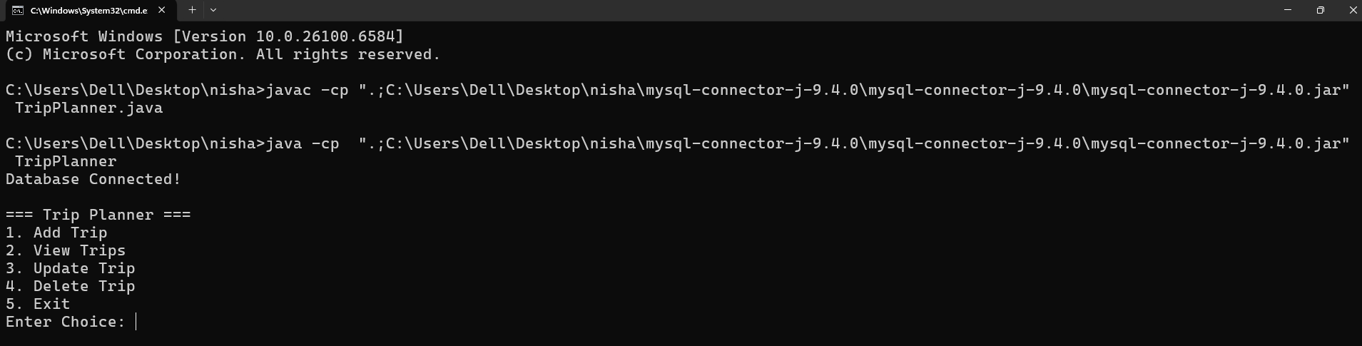

Add:
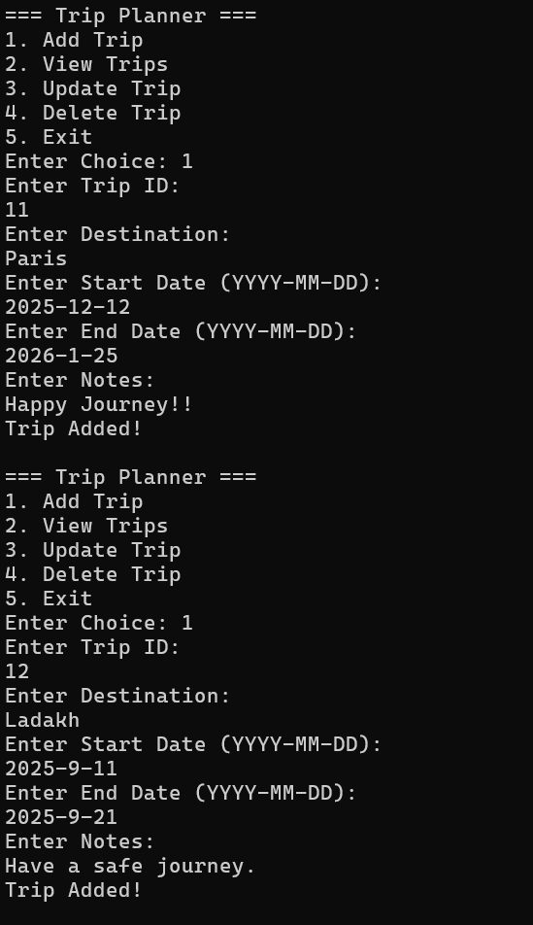

Database:
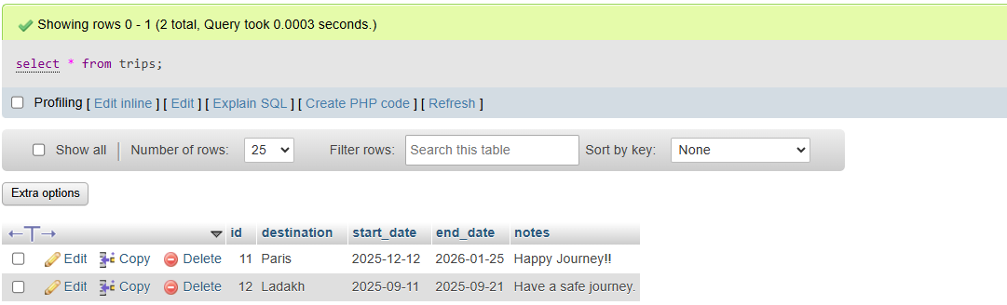

View:
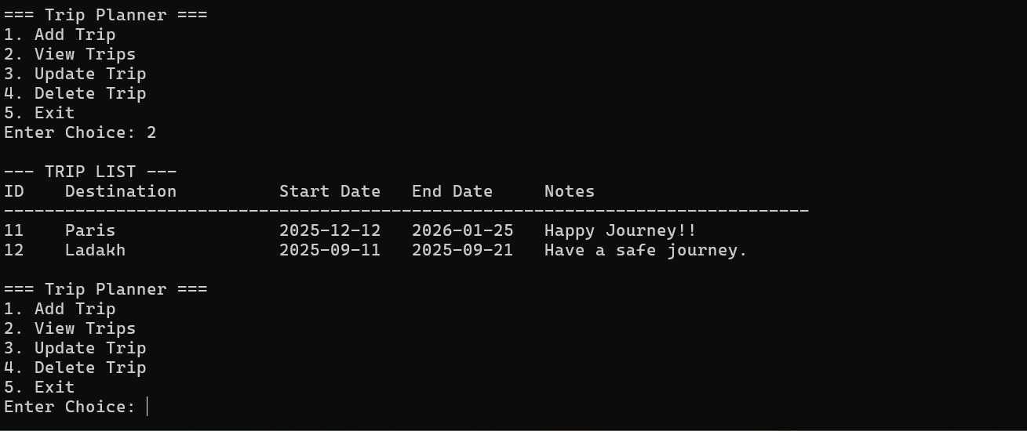

Update:

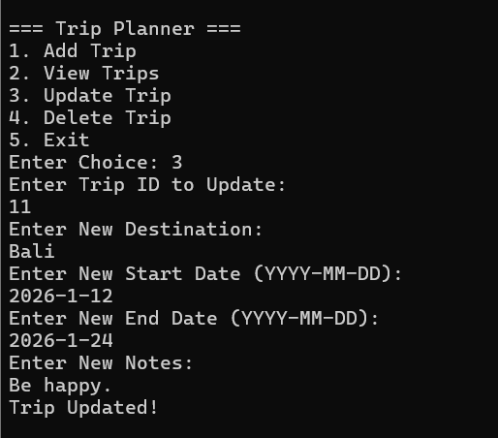

Database:

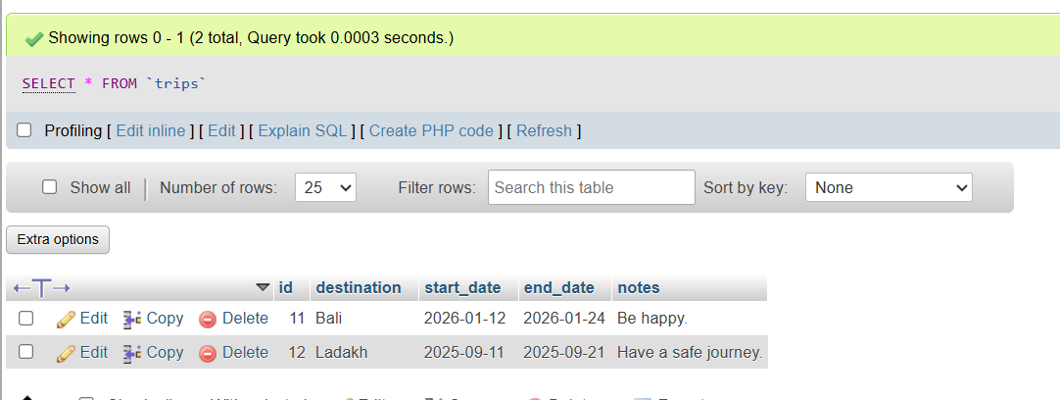
Delete:
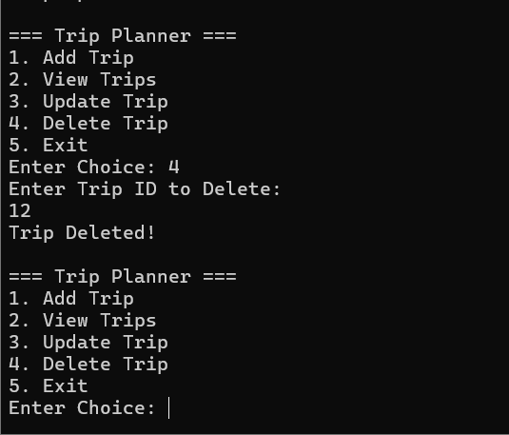

Database:
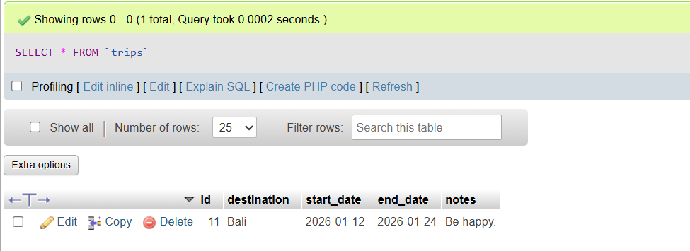

Software Requirement:

Software:
- Programming Language: Java (JDK 8 or above)
- Database: MySQL 5.7 / 8.0
- IDE: NetBeans / Eclipse / IntelliJ IDEA
- Connector: MySQL Connector/J (JDBC Driver)

Hardware:
- Processor: Intel i3 or higher
- RAM: 4 GB or more
- Hard Disk: Minimum 500 MB free space

Future Scope of the Project:
- Integration with a Graphical User Interface (GUI) using JavaFX or Swing.
- Adding modules for Customer Management, Sales, and Inventory Tracking.
- Implementation of search and filter functionality.
- Deployment as a web-based or mobile application using frameworks like Spring Boot or Android.
- Integration with cloud databases for scalability.

Conclusion :
The Nursery Plant Management System provides an efficient and reliable solution for managing plant-related data in a nursery. It simplifies record- keeping, improves data accuracy, and allows quick access to information. This project serves as a foundation for understanding Java database connectivity and can be extended into more advanced systems in the future.

Reference :
- Google Chrome

